DELIVERABLES – Machine Learning – DAY 2

Libraries used:
numpy (as np) - Numerical computing and array operations
pandas (as pd) - Data manipulation and analysis
matplotlib.pyplot (as plt) - Data visualization and plotting
scikit-learn (sklearn):
sklearn.datasets - Load the breast cancer dataset
sklearn.linear_model - LogisticRegression model
sklearn.model_selection - train_test_split for data splitting
sklearn.metrics - accuracy_score, precision_score, recall_score, f1_score, confusion_matrix, roc_curve, auc

ASSIGNMENT – K Means from Scratch
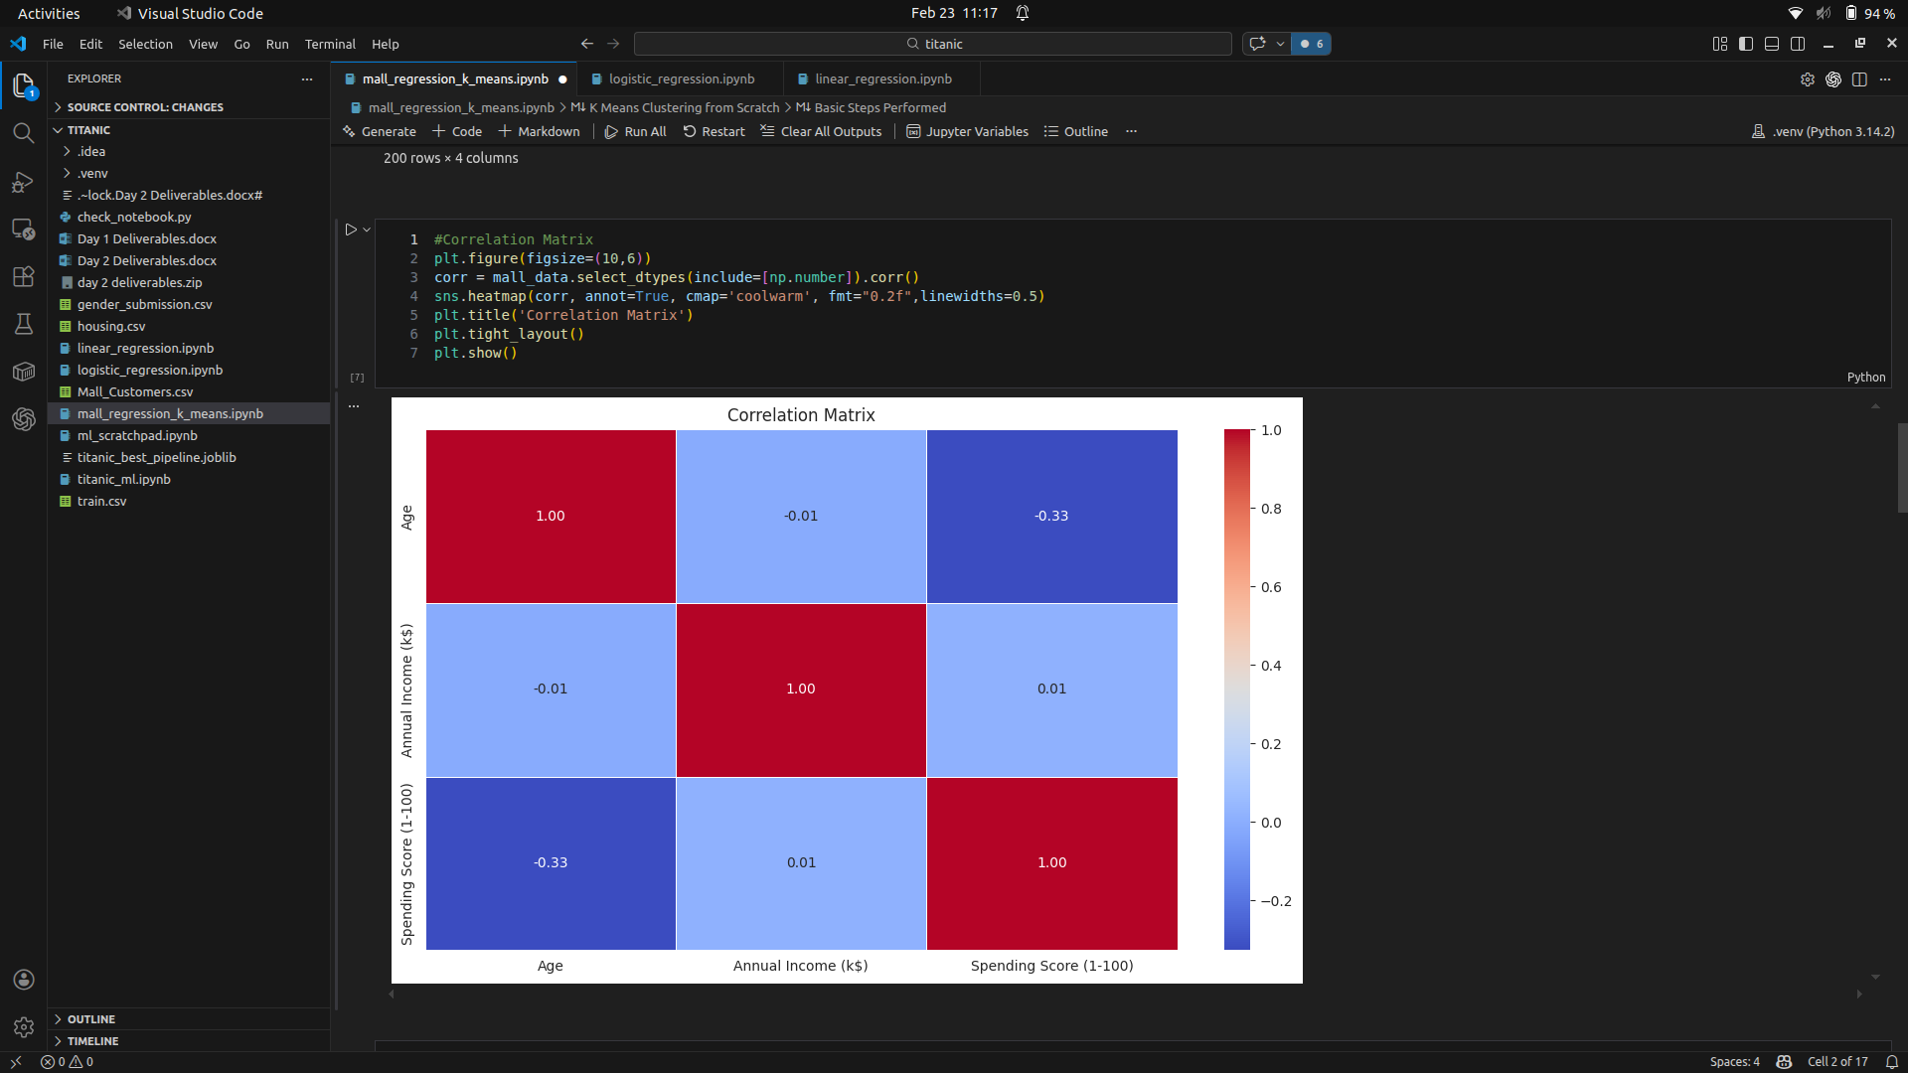

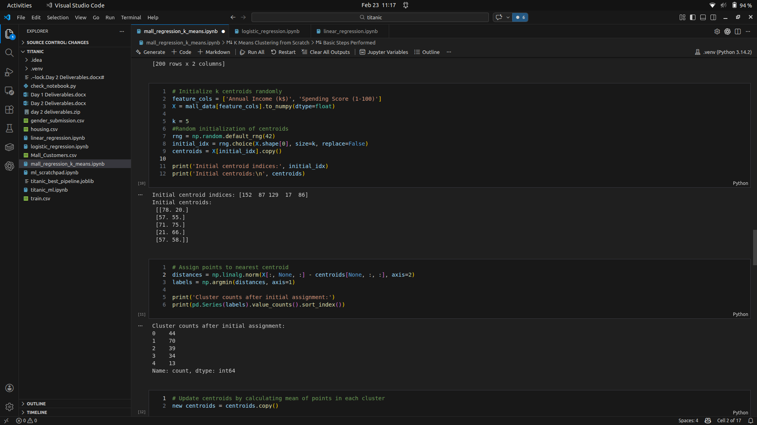

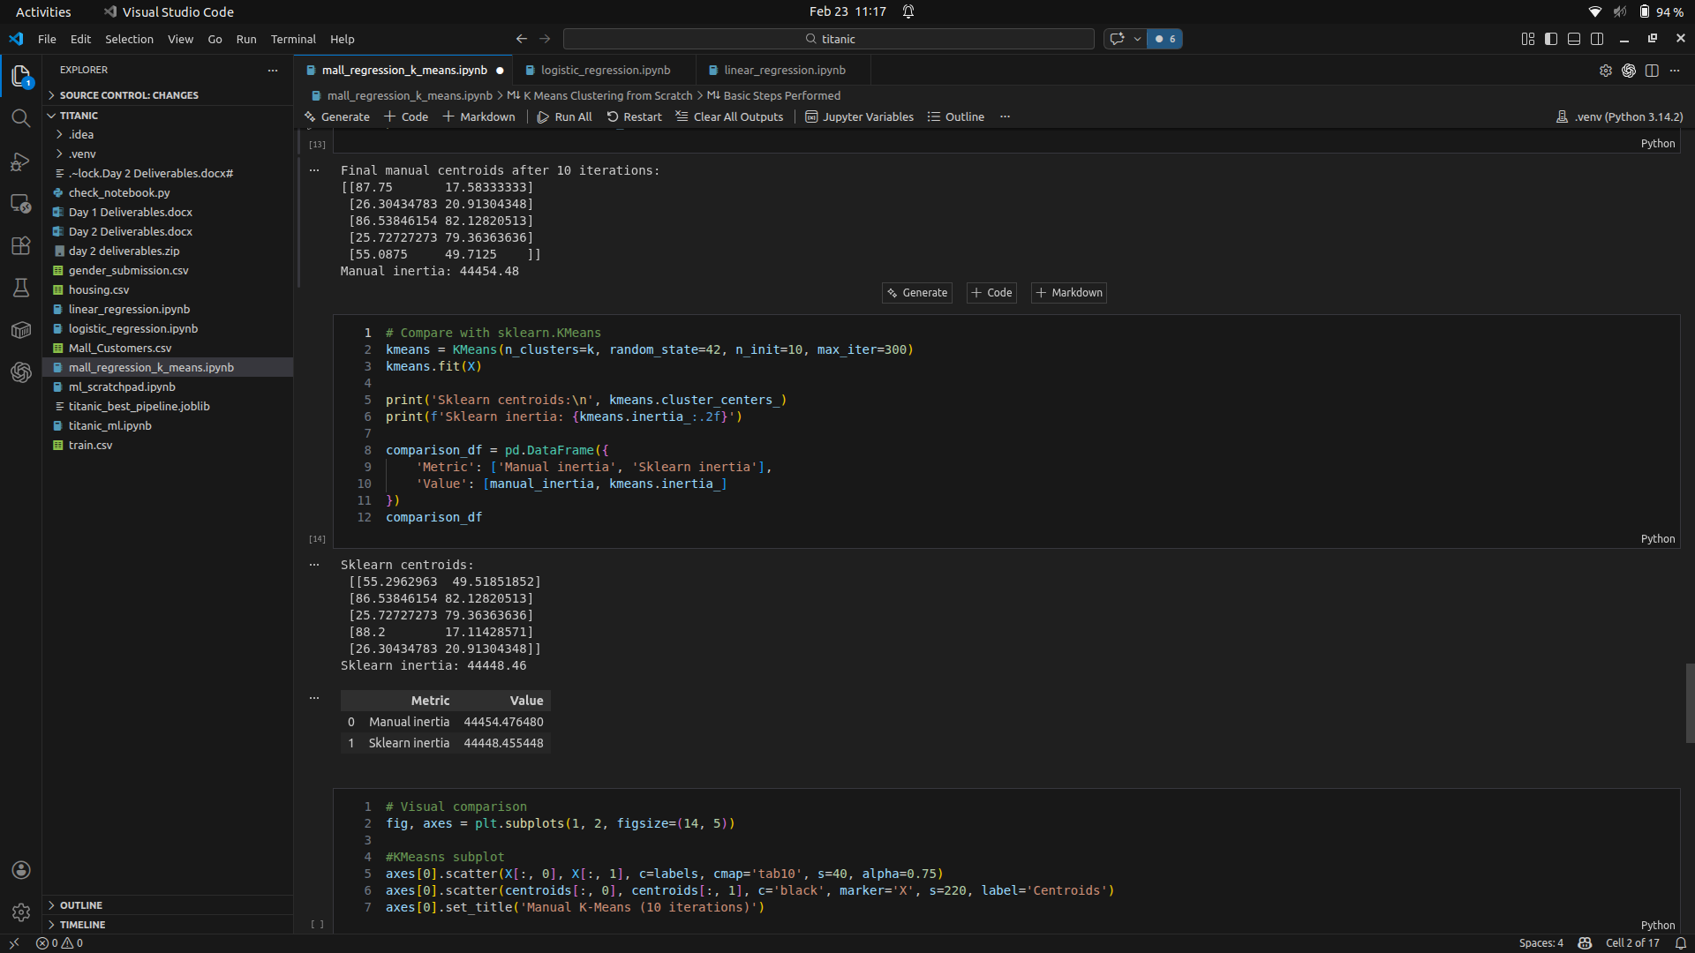

ASSIGNMENT – Linear Regression
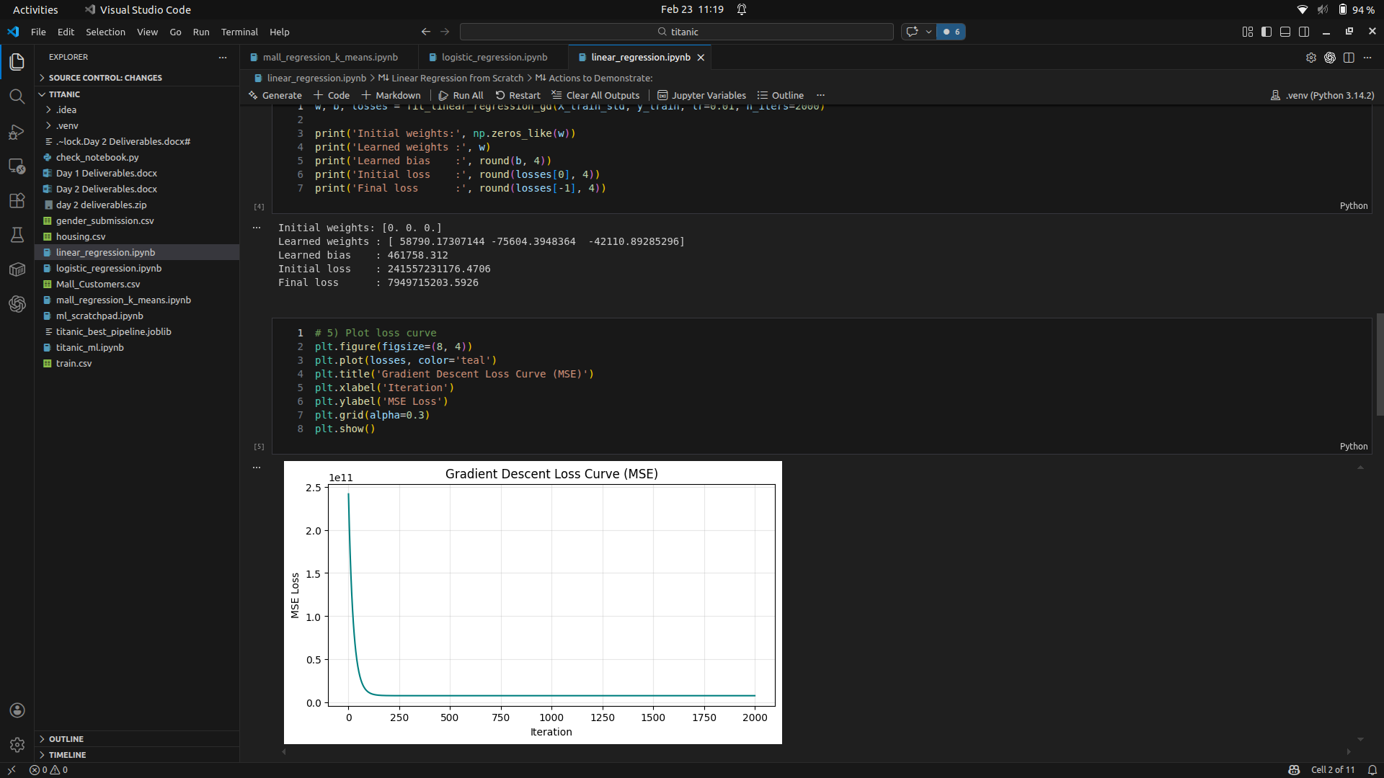

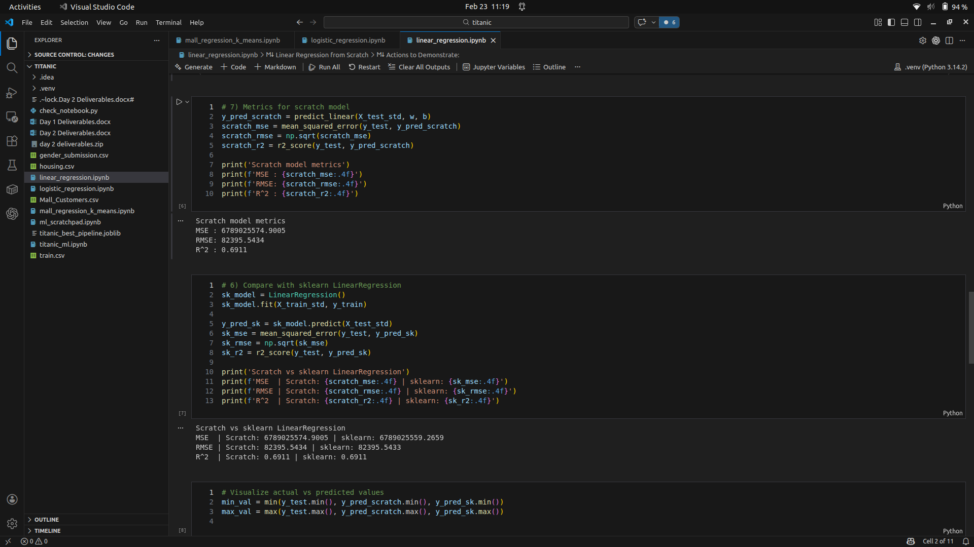
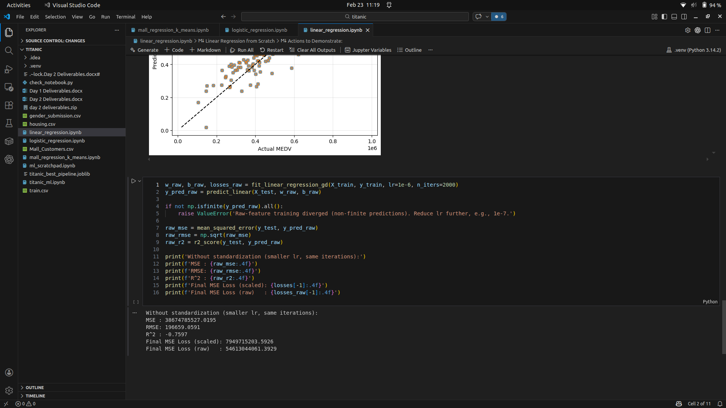
Metric Tradeoffs:
Accuracy is misleading with imbalanced classes; Precision prioritizes minimizing false positives (useful when errors are costly), while Recall minimizes false negatives (critical in medical/safety domains). F1-Score balances precision and recall, but treats both equally—use it when both error types matter. ROC-AUC is threshold-independent and excellent for comparing models, unaffected by class imbalance. Choose metrics based on domain: medical diagnosis needs high recall (catch all cases), spam detection needs precision (avoid false alarms), fraud detection needs F1-Score balance.

Model Fit:
Model fit refers to how well a trained model learns the underlying patterns in training data and generalizes to unseen test data. Underfitting occurs when the model is too simple to capture the underlying patterns, resulting in high bias and poor performance on both training and test data—the model "misses the mark." Overfitting happens when the model memorizes training data too closely, including noise, achieving near-perfect training accuracy but poor test performance due to high variance. Good fit is the sweet spot: the model captures true patterns without memorizing noise, performing well on both training and test sets. Signs of underfitting include consistently low accuracy across train/test; overfitting signs include high train accuracy but low test accuracy. Techniques like regularization, early stopping, and cross-validation help achieve optimal fit by balancing bias-variance trade-off.

ASSIGNMENT – Logistic Regression
